# LAB ASSIGNMENT-4

TASK-1:

Prompt:

write a function that checks whether a given year is a leap year.

Code and Output:

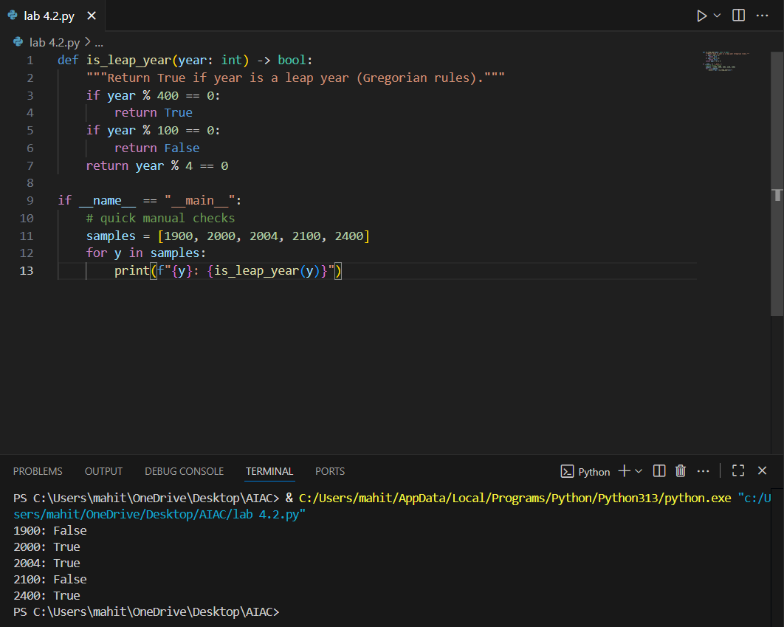

Code Explanation:

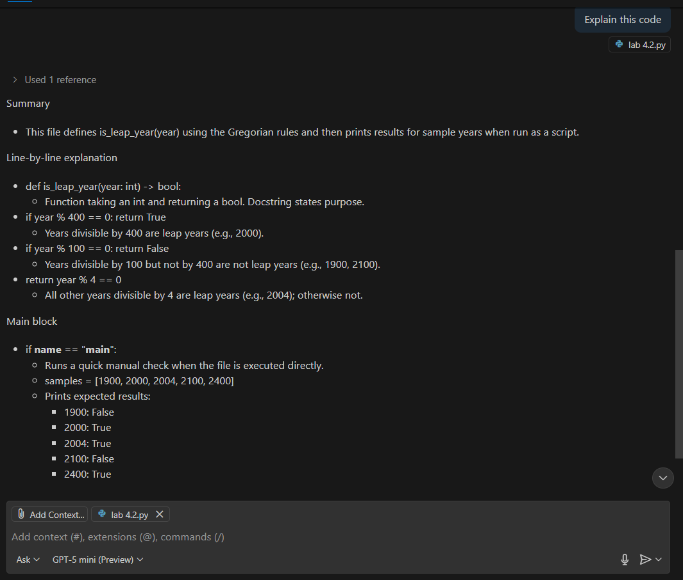

TASK-2:

Prompt:

write a python function that converts centimeters to inches.

Input: 7

Output: 2.75591

Code and Output:

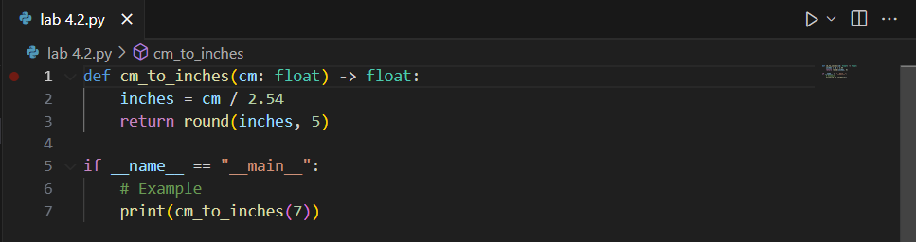

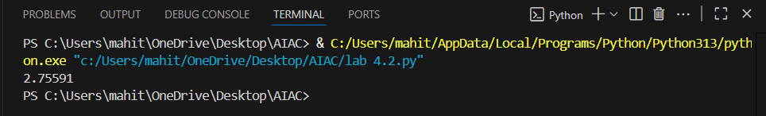

Code Explanation:

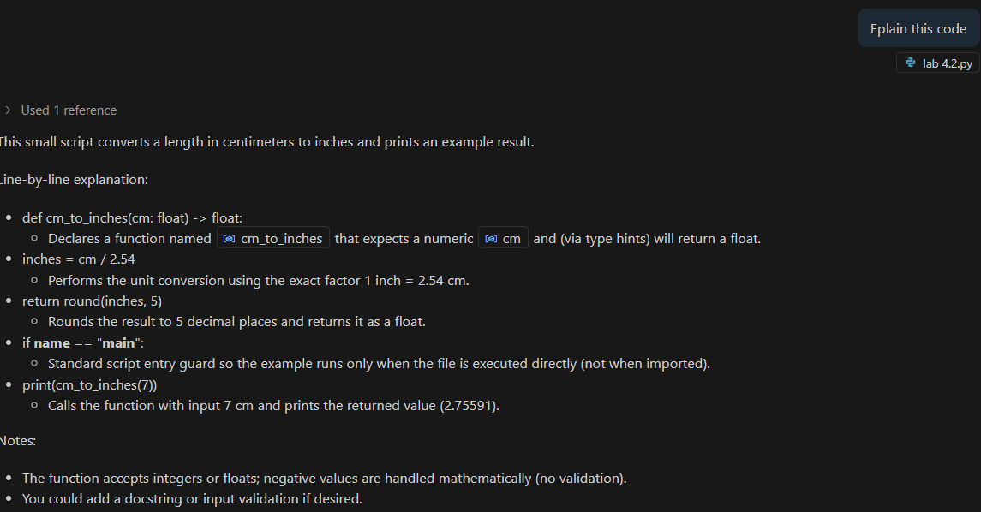

TASK-3:

Prompt:

write a python code using function that formats full names as “Last, First” where user enters full names

Examples inputs and outputs are:

Input: Naroju Mahitej

Output: "Naroju, Mahitej"

Input; Muthoju Sathya

output: "Muthoju, Sathya"

Input: Vengaldas Vivek

output: "Vengaldas, Vivek"

Code and Output:

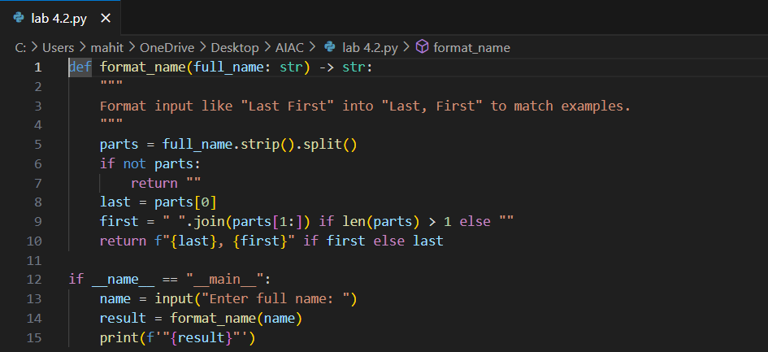

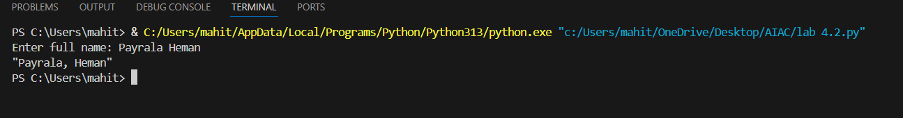

Code Explanation:

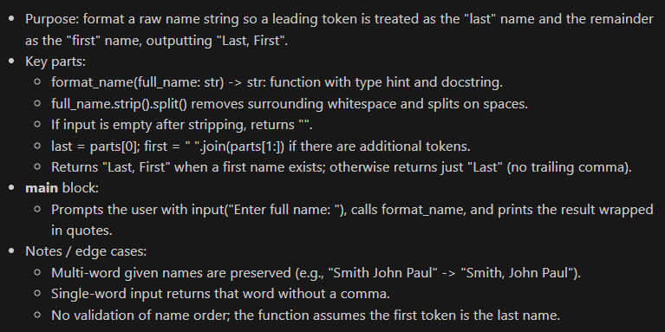

TASK-4:

Prompt:

Zero short:

writing a function that counts the number of vowels in a string.

Few short:

writing a function that counts the number of vowels in a string.

Examples of input and outputs are:

input: Apple

output: Vowel count: 2

input: Mango

output: Vowel count: 2

Code and Output:

Zero short:

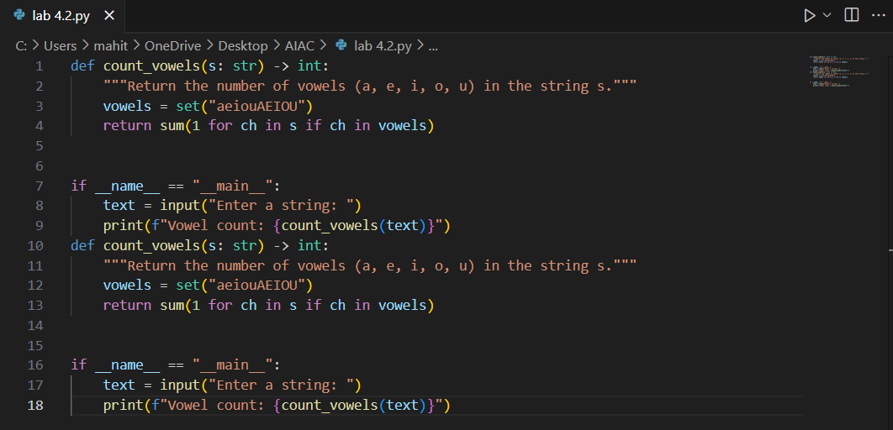

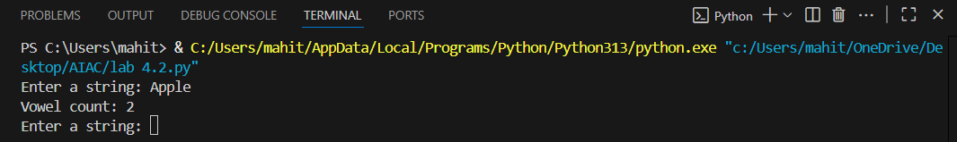

Few short:

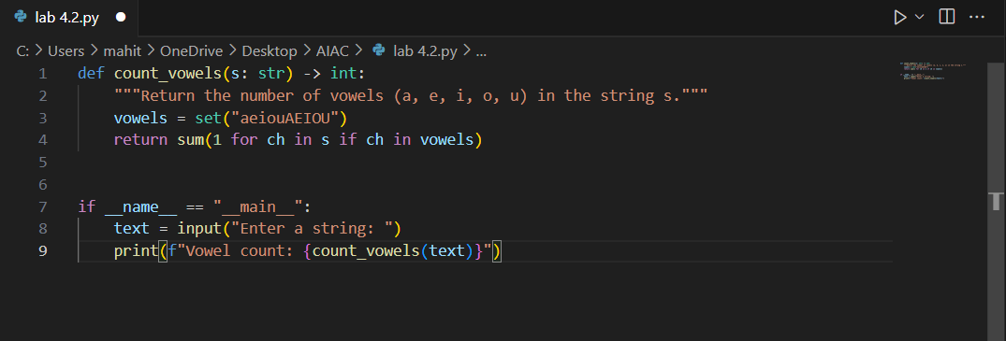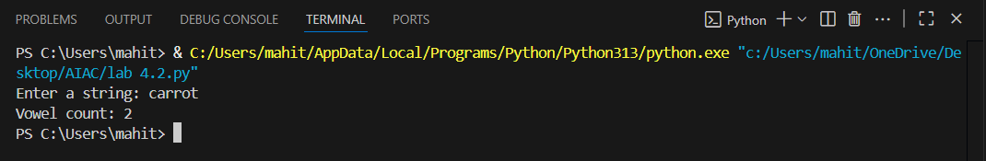

Code Explanation:

Functional output and comparative reflection:

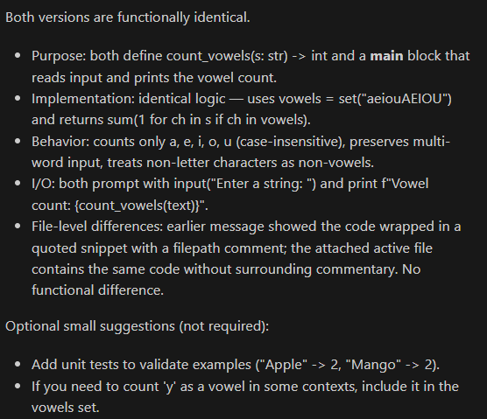

TASK-5:

Prompt:

# Example 1

Function: Reads a .txt file and returns the number of words.

def count_words_in_file(path: str) -> int:

with open(path, 'r', encoding='utf-8') as f:

return sum(len(line.split()) for line in f)

if __name__ == "__main__":

sample_path = r"C:\Users\mahit\OneDrive\Desktop\AIAC\apple.txt"

try:

print(count_words_in_file(sample_path))

except Exception as e:

print("Error:", e)

# Example 2

Function: Reads a .txt file and returns the number of characters.

def count_chars_in_file(path: str) -> int:

with open(path, 'r', encoding='utf-8') as f:

return len(f.read())

if __name__ == "__main__":

sample_path = r"C:\Users\mahit\OneDrive\Desktop\AIAC\apple.txt"

try:

print(count_chars_in_file(sample_path))

except Exception as e:

print("Error:", e)

Now,generate a function that reads a .txt file and returns the number of lines

Code and Output:

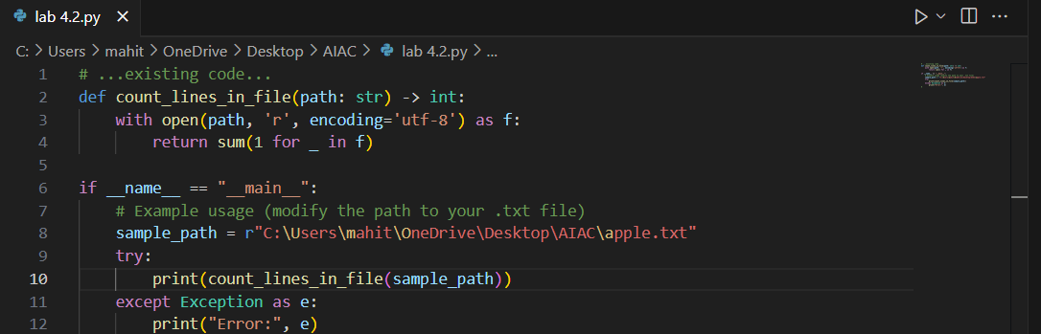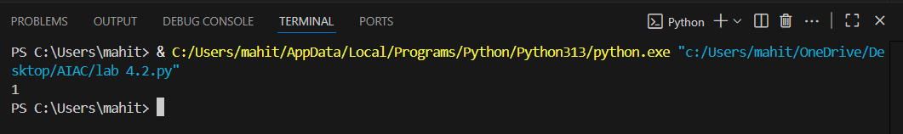

Code Explanation:

